System Overview of a Virtual Payment Platform for Issuing and Managing Virtual Cards
Introduction
This report presents the system overview of a virtual payment platform that provides users with virtual cards for online transactions. The system integrates user authentication, wallet management, transaction processing, and caching using Redis.
System Objectives
The main objective of the platform is to enable secure and efficient virtual payments by integrating third-party APIs for virtual cards and wallet services, ensuring fast transaction processing through caching and optimized data handling.
System Modules
- Authentication & User Management Module: This module ensures that all users of the platform are properly authenticated before accessing any services. It generates secure tokens that verify user identity and interacts with the database to manage user information.
- Virtual Card Service (via 3rd Party API): The Virtual Card Service module handles the creation and management of virtual cards through a secure connection with a third-party API. It allows users to generate, view, and manage their virtual cards efficiently.
- Walleting System (via 3rd Party API): The Walleting System module allows users to store funds and perform transactions safely. It interacts with a third-party wallet service to enable deposits, balance checks, and transfers while maintaining security and accuracy.
- Transaction System (with Redis): The Transaction System module uses Redis to improve speed and reliability and improve response times. It ensures that all user transactions are processed reliably and efficiently.
Architecture Overview
The Architecture Overview is a high-level representation of a system that illustrates its main components, their roles, and how they interact to perform the system’s functions. It provides a comprehensive view of the structure, data flow, and communication between modules, supporting services, databases, and third-party integrations, helping stakeholders understand the design and operation of the platform. They are seen as follows;
- Client/Server Architecture Diagram: It shows how the client (mobile app/web app) communicates with the server.

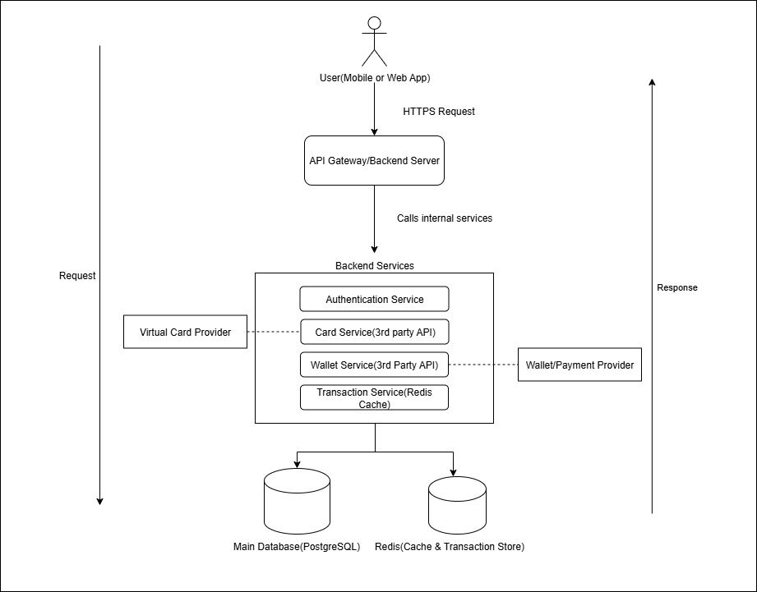
Figure 1: Client/Server Architecture for Request-Response Cycle

Figure 1 shows the client/server architecture of the virtual payment platform. The mobile client sends HTTPS requests to the API Gateway, which routes requests to the appropriate services. The server then processes the request and returns an HTTPS response to the client.
- Redis Caching Architecture Diagram: Shows how Redis is used to speed up transactions and caching.
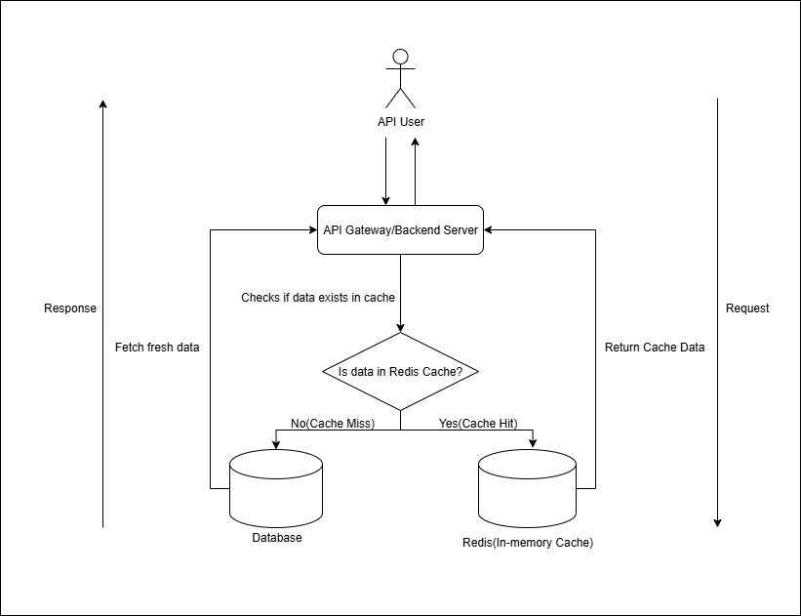
Figure 2: Redis Caching Architecture
Figure 2 demonstrates how the transaction system interacts with Redis for caching. When a request is made, the API Server first checks Redis:
- Cache Hit: Data is returned instantly from Redis.
- Cache Miss: Data is retrieved from the main database and then stored in Redis for future requests.
- Overall System Architecture Diagram: Shows the entire system including Edge Services, Microservices, Databases, Redis, and Third-Party APIs.
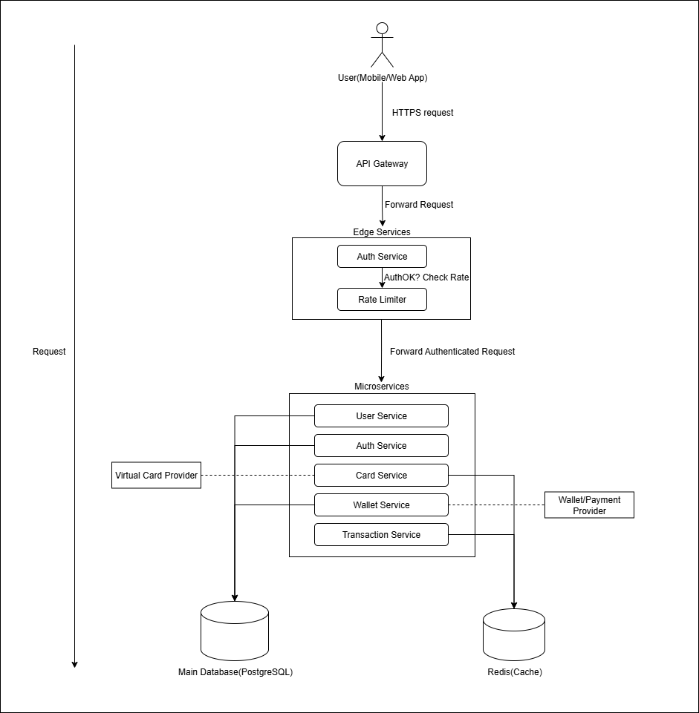
Figure 3: Overall System Architecture of the Virtual Payment Platform

Figure 3 provides the overall architecture of the platform. The Edge Services layer includes the API Gateway, Authentication Service, and Rate Limiter. Requests are routed to the Microservices layer, which contains the Wallet Service, Card Service, and Transaction Service. Redis is used for caching, and PostgreSQL stores permanent data. Third-party providers supply virtual card and wallet functionalities.
Recommended Programming Languages and Database Management System
- Programming Languages
Backend:
- Node.js (JavaScript/TypeScript)
Why:
-Handles high concurrency and real-time transactions efficiently.
-Lightweight and scalable for microservices architecture.
-Large ecosystem of libraries for API development and third-party integrations.
Frontend / Mobile App:
- React Native
Why:
- Enables cross-platform mobile development (iOS and Android) with a single codebase.
- Smooth user interface and fast performance.
- Database Management System (DBMS)
Primary Database:
- PostgreSQL
Why:
- Provides extremely fast data access for frequently requested information (e.g., recent transactions, session tokens).
- Reduces load on the main database and improves system performance.
- Perfect for transaction processing and caching in real-time systems.
Cache / In-Memory DB:
- Redis
Why:
- Provides extremely fast data access for frequently requested information (e.g., recent transactions, session tokens).
- Reduces load on the main database and improves system performance.
- Perfect for transaction processing and caching in real-time systems.
The virtual payment platform demonstrates a scalable, secure, and efficient financial system that integrates third-party APIs and caching technologies to optimize performance and user experience.

